Lab 01 : Introduction & Review
Exercise 01 : Choose the right answer :
- What is the main function of a compiler?
(a) Execute the program directly
(b) Translate source code into machine code
(c) Debug programs automatically
(d) Interpret code line by line

- Which of the following is NOT a phase of compilation?
(a) Lexical analysis
(b) Syntax analysis
(c) Machine execution
(d) Code optimization

- Which phase of the compiler converts high-level code into tokens?
(a) Syntax analysis
(b) Lexical analysis
(c) Semantic analysis
(d) Code generation

- Which of these best describes an interpreter?
(a) Translates the entire program at once
(b) Converts source code into assembly language
(c) Translates and executes code line by line
(d) Generates an executable file

- Which component checks for syntactic errors in a program?
(a) Semantic analyzer
(b) Code generator
(c) Syntax analyzer (parser)
(d) Optimizer

- What is the difference between a compiler and an interpreter?
(a) A compiler translates code all at once, while an interpreter does it line by line
(b) A compiler executes code directly, while an interpreter translates it first
(c) A compiler is used for low-level languages only
(d) An interpreter is always faster than a compiler

- Which of the following is an example of an interpreted language?
(a) C
(b) Java
(c) Python
(d) Assembly

- Which of the following is NOT a role of the semantic analysis phase?
(a) Checking type consistency
(b) Ensuring variables are declared before use
(c) Generating machine code
(d) Checking function parameter matching

- What is an intermediate representation (IR) in a compiler?
(a) The final machine code
(b) A representation between source code and machine code
(c) A high-level programming language
(d) The error messages produced by a compiler

- Which of the following is NOT a front-end phase of a compiler?
(a) Lexical analysis
(b) Syntax analysis
(c) Code optimization
(d) Semantic analysis

Exercise 02: For each of the following code, determine whether the error is lexical, syntactic, or semantic.

Code A:
int main() {
char *str = "Hello;
printf("%s", str);
return 0;
}

Code B:
int main() {
int x;
printf("%d", x);
return 0;
}

Code C:
int main() {
int num = "Text";
printf("%d", num);
return 0;}

Code D:
int main() {
int x = 10;
float y = x / 0;
printf("Result: %f", y);
return 0;
}

Code E
int x = 10.5;
if (x == ) {}
printf("%d", y);

Code F
int main() {
int 9num = 5;
printf("%d", 9num);
return 0;
}

Code G
int main() {
int x = 10
printf("%d", x);
return 0;}

Exercise 03 : Consider the string: abbbaacc. Which lexical specification(s) produce the following tokenization: ab/bb/a/acc ?
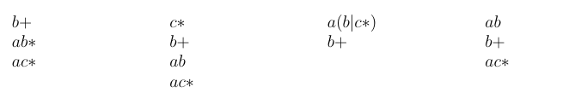

Verify the answers using Lex.

